**Documentation**

**Functionalities Implemented**

**● Accepts the user data, does basic validations**

**● Store the data in database**

**Technologies used:**

Frontend: React.js

Backend: Springboot

Database: AWS(MySQL)

**Reasons for choosing React.js:**

It is Flexible

Has a Great Developer Experience

Great Performance

Easy to Test

**Reasons for choosing Springboot:**

Faster Development

There is starter for everything

Embedded web Servers

Rich IDE Support for Springboot

**Reasons for choosing MySQL:**

MySQL is the world's most popular open source relational database and Amazon RDS makes it easer to set up, operate, and scale MySQL deployments in the cloud. With Amazon RDS, you can deploy scalable MySQL servers in minutes with cost-efficient and resizable hardware capacity.

Amazon RDS for MySQL frees you up to focus on application development by managing time-consuming database administration tasks, including backups, upgrades, software patching, performance improvements, monitoring, scaling, and replication.

**Table:**

**Customer**   
**Columns:**

|  |  |
| --- | --- |
| **id** | bigint AI PK |
| age | int |
| firstname | varchar(255) |
| lastname | varchar(255) |
| batch | varchar(255) |
| email_id | varchar(255) |

**ER diagram:**

For now I have just implemented Customer Entity

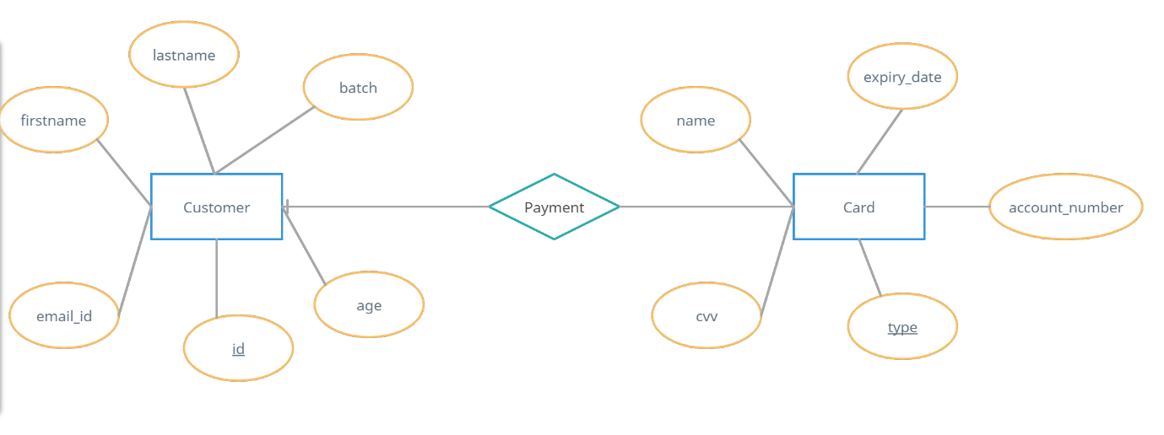

**Screenshots:**

When First name column is empty-error pops up.

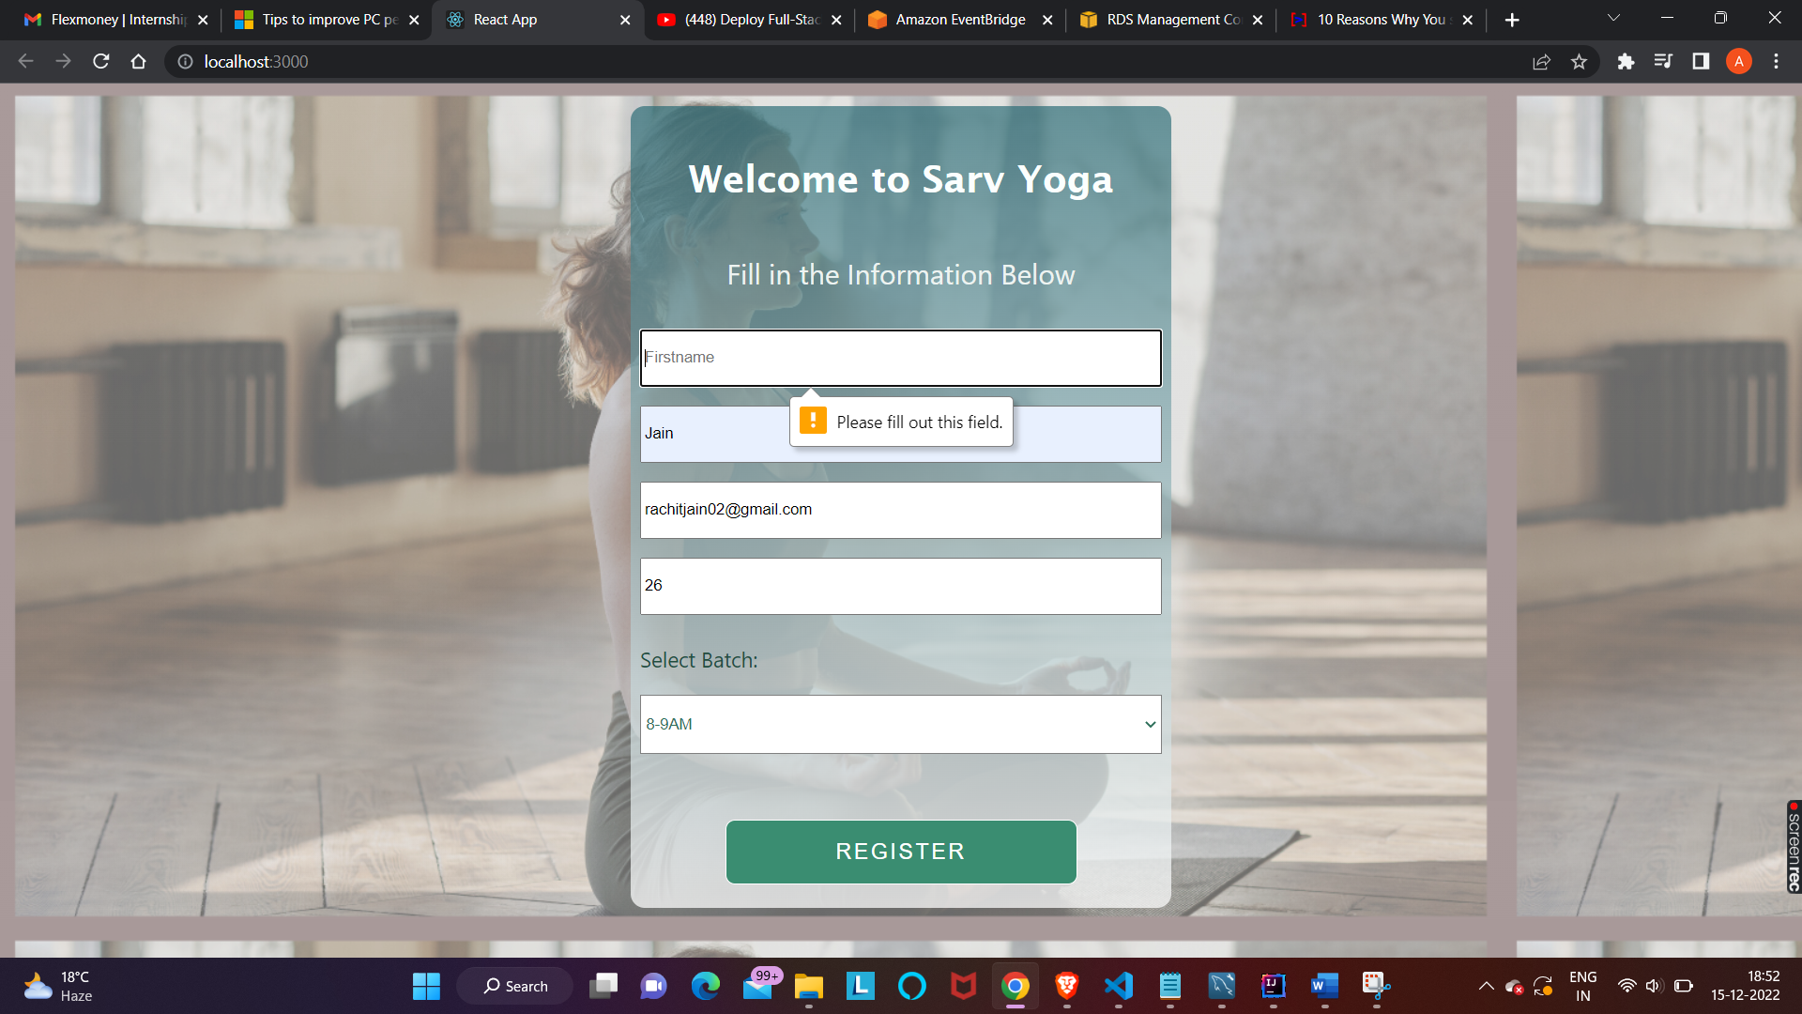

When Last name column is empty-error pops up.

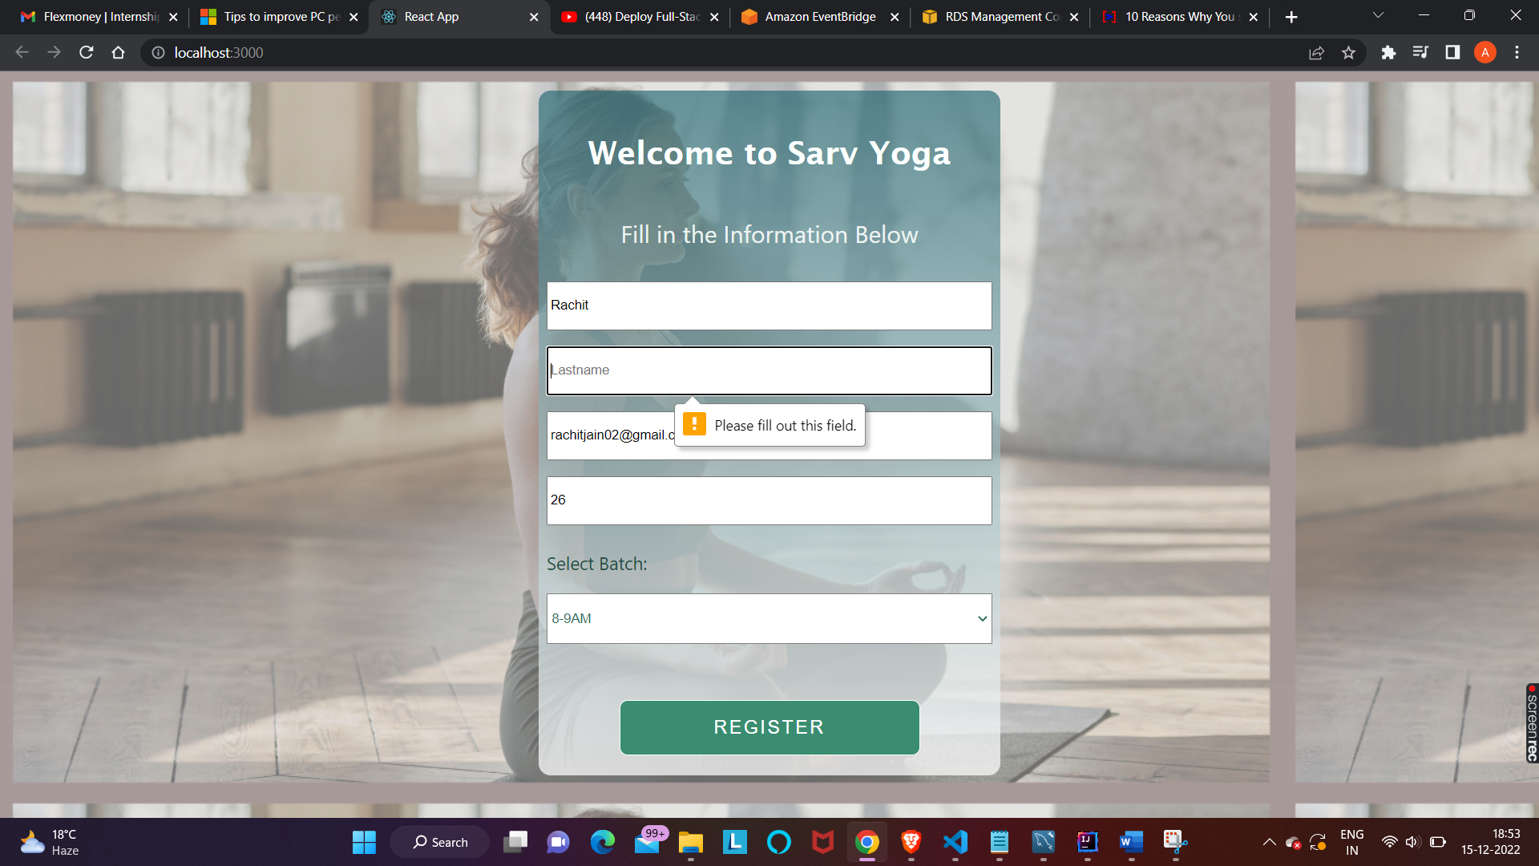

When Email id column is empty-error pops up.

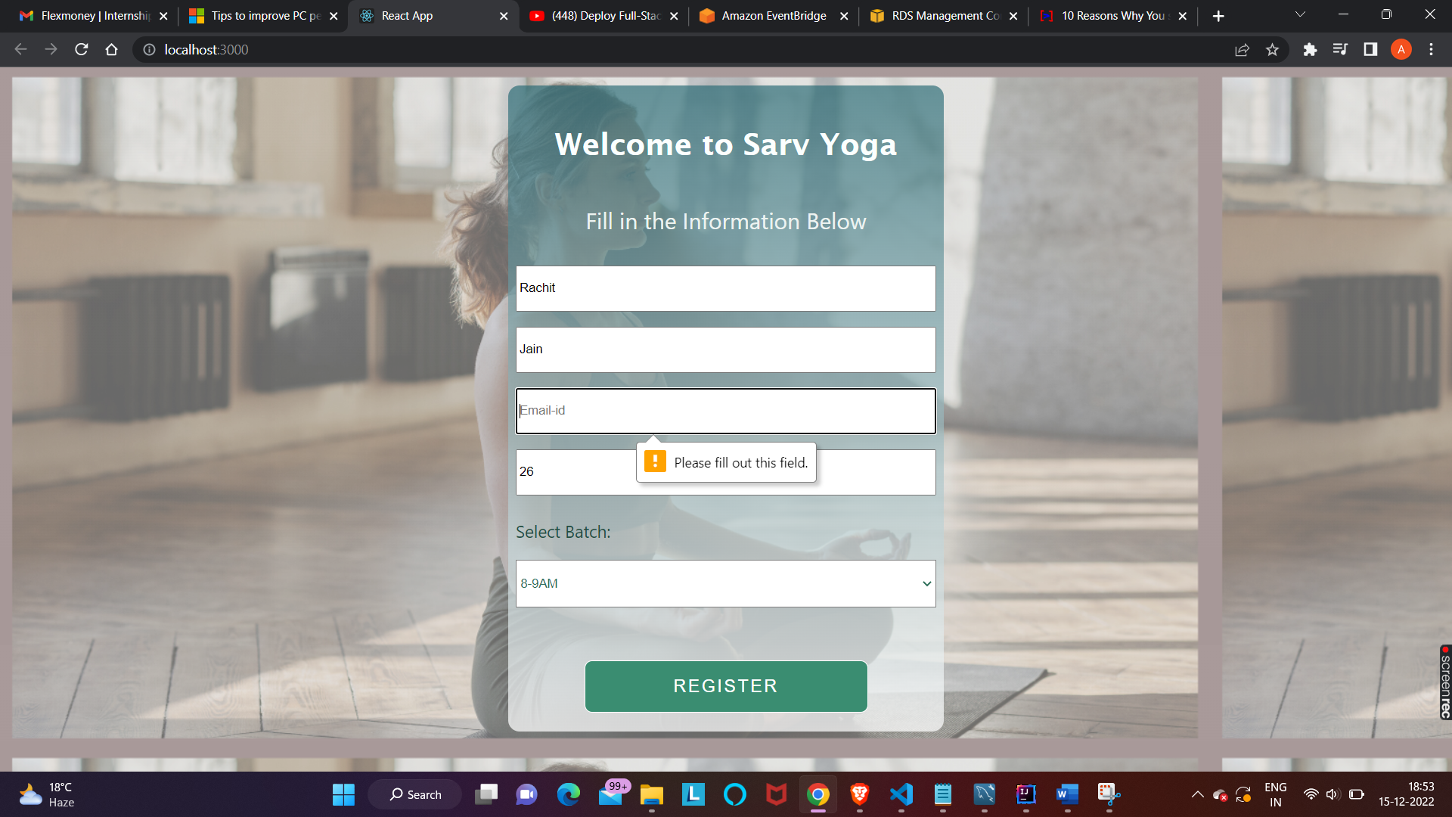

When Email id input format is not correct-error pops up.

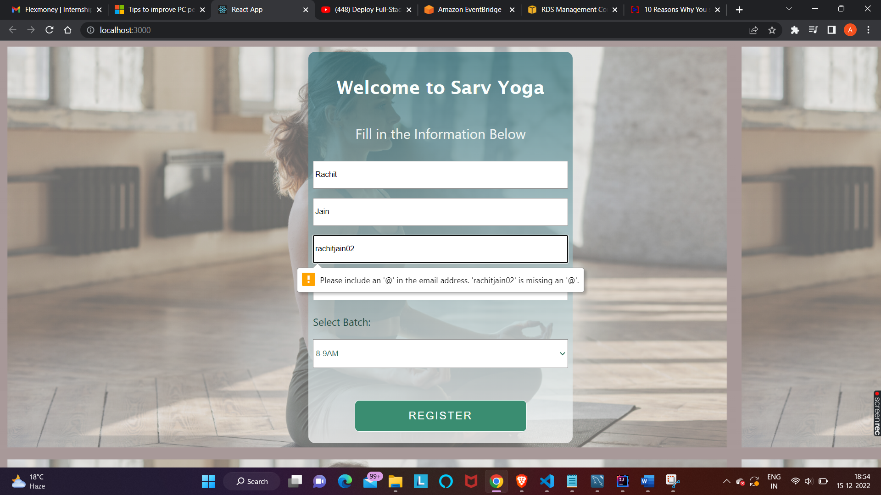

When Age column is empty-error pops up.

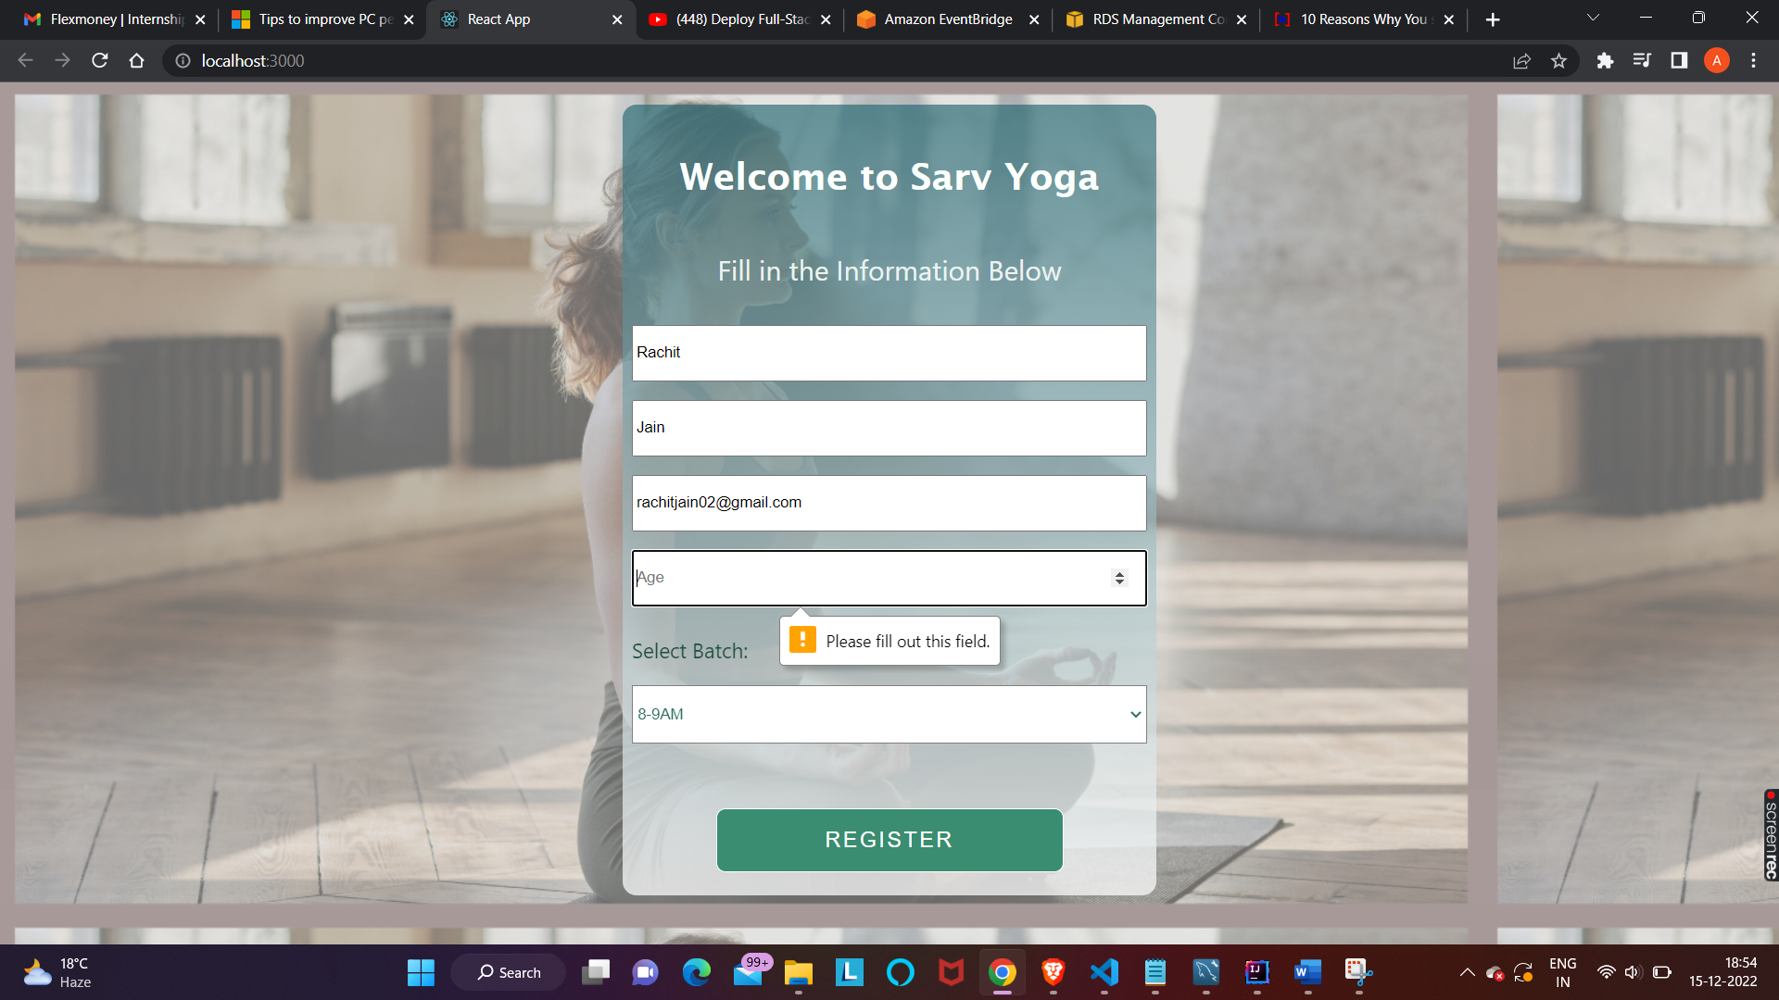

When value in Age column is more than 65-error pops up.

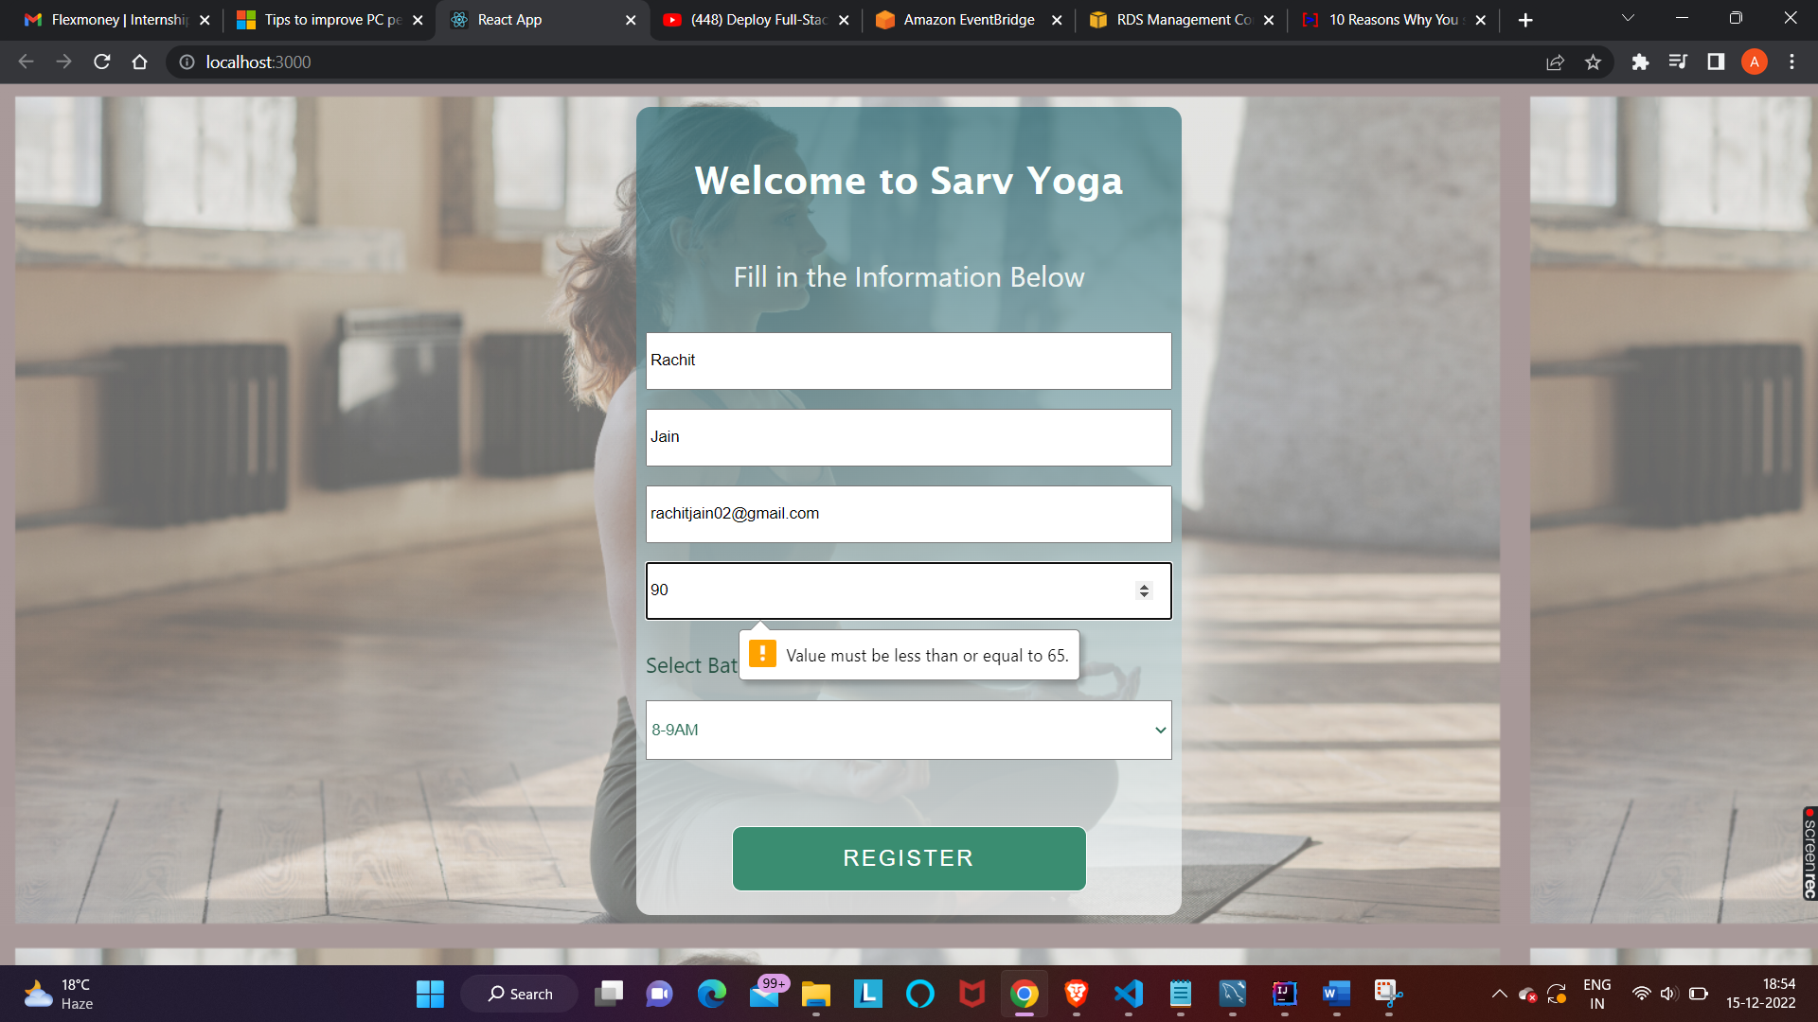

When value in Age column is less than 18-error pops up.

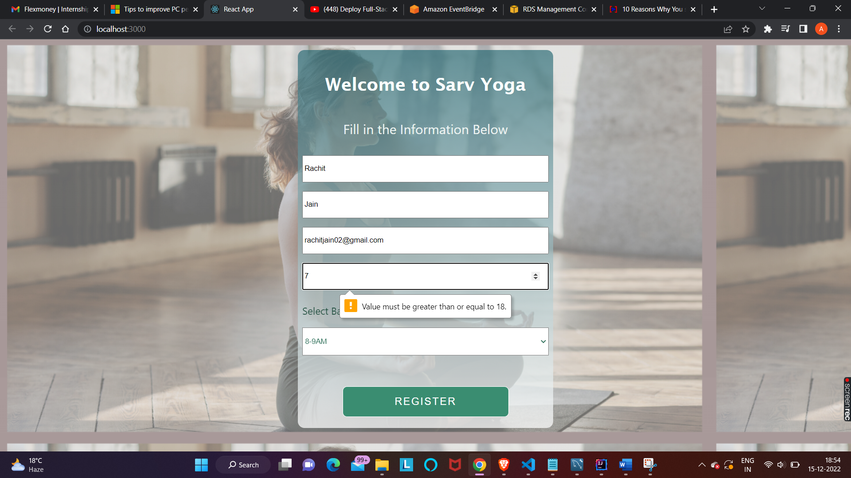

Customers can choose from different batches.

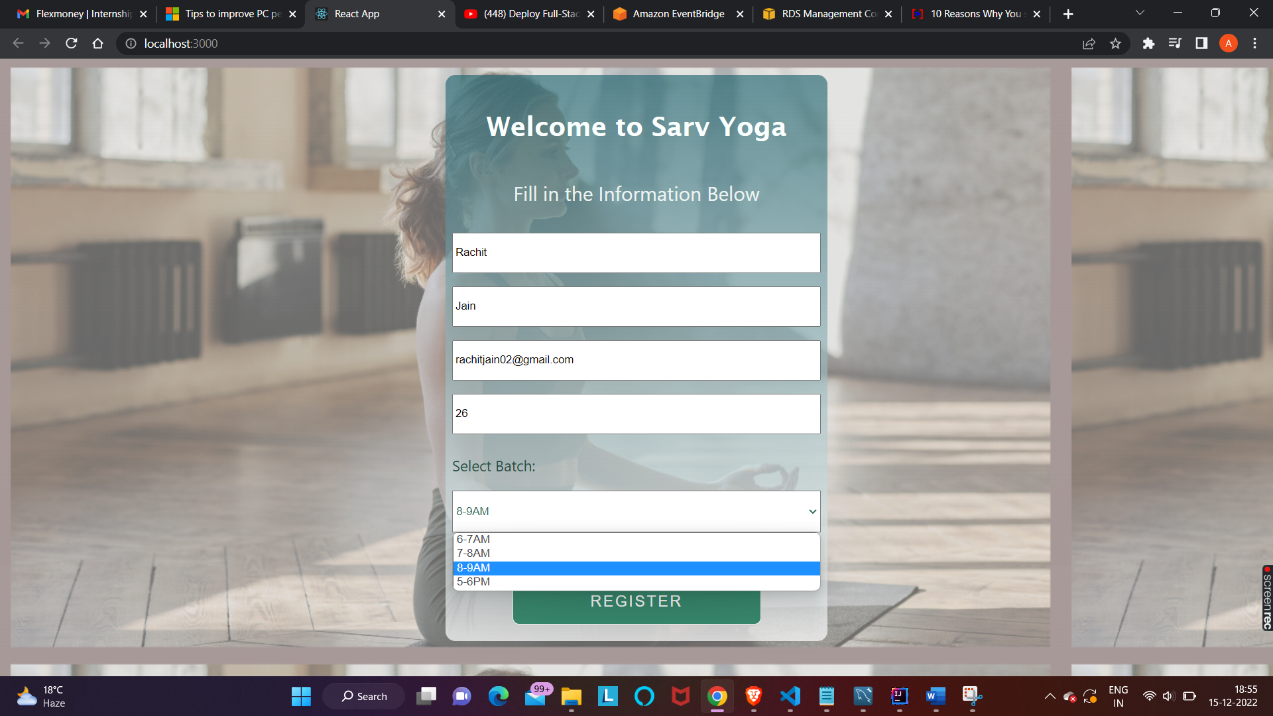

Register the record.

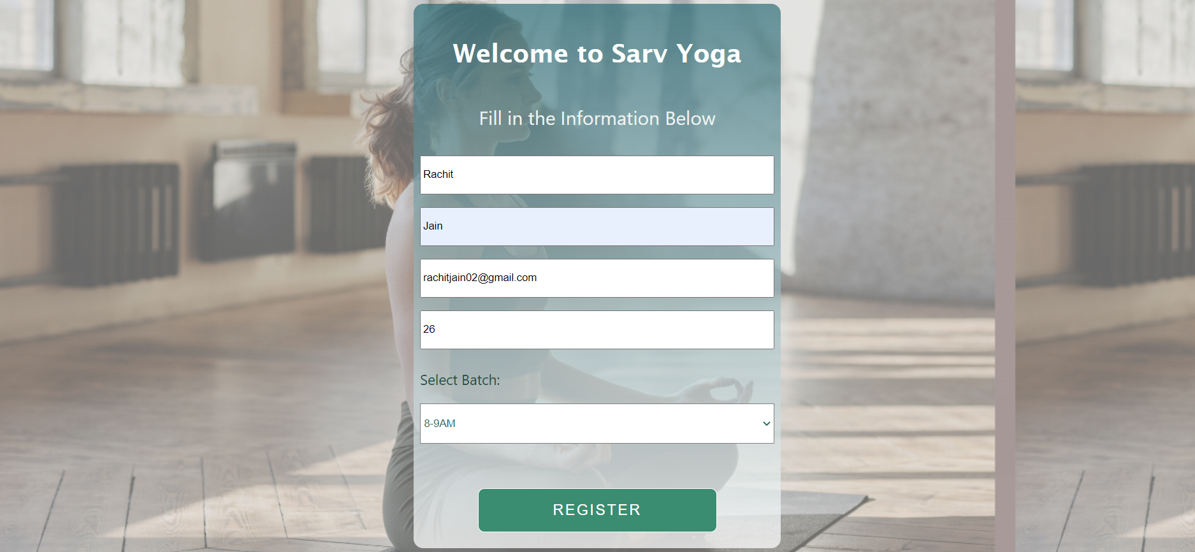

The record is reflected in the database.

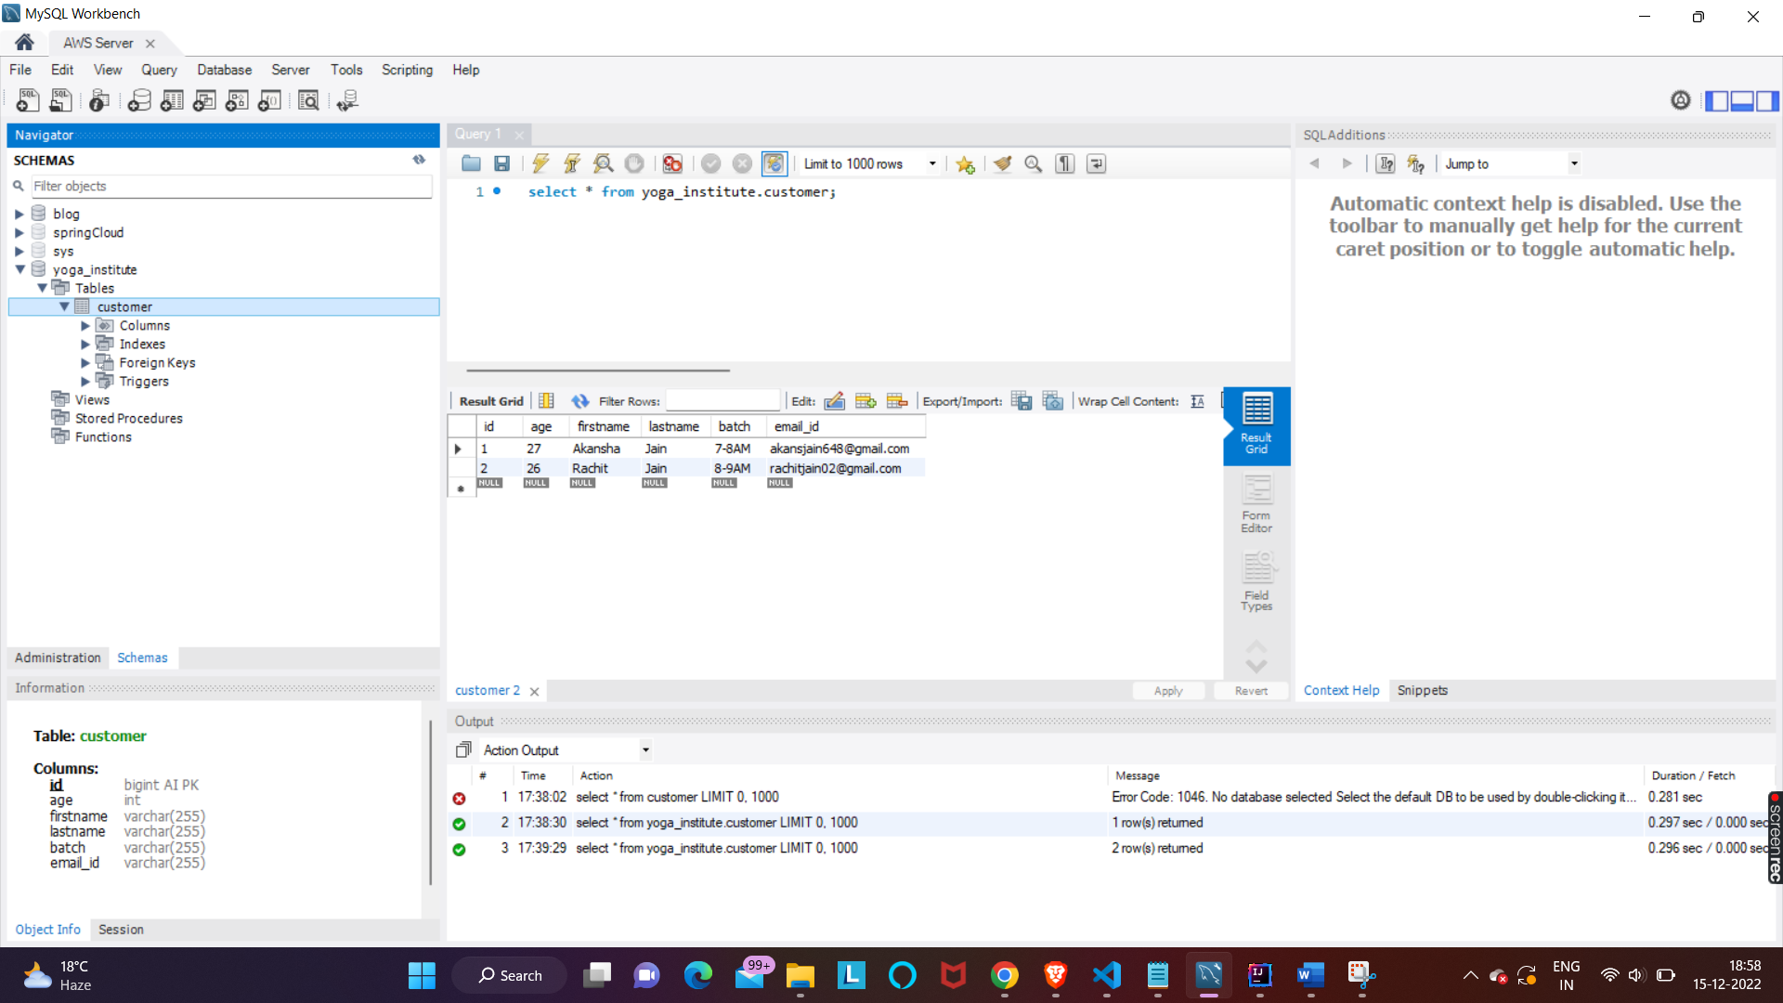

**Source Code:**

I have created the table name  which is records in the database. this annotation  **@Table(name=”Records”)** indicate the table name of the database.

1. Entity annotation @Entity indicate as Entity of class.
2. Column annotation @Column indicate each column of the table.

Customer.java

package com.example.YogaInstitute.entity;  
  
import jakarta.persistence.*;  
  
@Entity  
@Table(name = "Customer")  
public class Customer {  
  
  
 @Id  
 @Column(name="id")  
 @GeneratedValue(strategy = GenerationType.*IDENTITY*)  
 private long id;  
  
 @Column(name = "firstname")  
 private String firstname;  
  
 @Column(name = "lastname")  
 private String lastname;  
  
 @Column(name = "email_id")  
 private String email_id;  
  
 @Column(name = "age")  
 private int age;  
  
 @Column(name = "batch")  
 private String batch;  
  
 public long getId() {  
 return id;  
 }  
  
 public void setId(long id) {  
 this.id = id;  
 }  
  
 public String getFirstname() {  
 return firstname;  
 }  
  
 public void setFirstname(String firstname) {  
 this.firstname = firstname;  
 }  
  
 public String getLastname() {  
 return lastname;  
 }  
  
 public void setLastname(String lastname) {  
 this.lastname = lastname;  
 }  
  
 public int getAge() {  
 return age;  
 }  
  
 public void setAge(int age) {  
 this.age = age;  
 }  
  
 public String getBatch() {  
 return batch;  
 }  
  
 public void setBatch(String batch) {  
 this.batch = batch;  
 }  
  
 public String getEmail_id() {  
 return email_id;  
 }  
  
 public void setEmail_id(String email_id) {  
 this.email_id = email_id;  
 }  
}

after that I have created the package **com.example.YogaInstitute.controller .**inside the package you have to create the class

CustomerController.js

package com.example.YogaInstitute.controller;  
  
import com.example.YogaInstitute.entity.Customer;  
import com.example.YogaInstitute.service.CustomerService;  
import org.springframework.beans.factory.annotation.Autowired;  
import org.springframework.web.bind.annotation.*;  
  
@RestController  
@CrossOrigin(origins = "*")  
  
public class CustomerController {  
 @Autowired  
 private CustomerService services;  
  
 @GetMapping("/")  
 public Iterable<Customer>getCustomers(){  
 return services.listAll();  
 }  
  
 @PostMapping(value = "/save")  
 private long saveCustomer(@RequestBody Customer customers){  
 services.saveOrUpdate(customers);  
 return customers.getId();  
 }  
  
 @RequestMapping("/customer/{id}")  
 private Customer getCustomer(@PathVariable(name = "id") int customerid){  
 return services.getCustomerbyId(customerid);  
 }  
  
 @PutMapping("/edit/{id}")  
 private Customer update(@RequestBody Customer customers, @PathVariable int id){  
 customers.setId(id);  
 services.saveOrUpdate(customers);  
 return customers;  
 }  
  
 @DeleteMapping("/delete/{id}")  
 private void deleteCustomer(@PathVariable("id") int id){  
 services.delete(id);  
 }  
}

Created the package **com.example.YogaInstitute.service .** inside the package I have created the class

CustomerService.java

package com.example.YogaInstitute.service;  
  
import com.example.YogaInstitute.entity.Customer;  
import com.example.YogaInstitute.repository.CustomerRepository;  
import org.springframework.beans.factory.annotation.Autowired;  
import org.springframework.stereotype.Service;  
  
@Service  
public class CustomerService {  
  
 @Autowired  
 private CustomerRepository repo;  
  
 public Iterable<Customer> listAll(){  
 return this.repo.findAll();  
 }  
  
 public void saveOrUpdate(Customer customers){  
 repo.save(customers);  
 }  
  
 //saving a record by using findbyId() of CrudRepository  
 public Customer getCustomerbyId(long id){  
 return repo.findById(id).get();  
 }  
  
 public Customer get(long id){  
 return repo.findById(id).get();  
 }  
  
 public void delete(long id){  
 repo.deleteById(id);  
 }  
  
}

Created the package **com.example.YogaInstitute.repository**inside the package I have created the Interface here.

EmployeeRepository.java

package com.example.YogaInstitute.repository;  
  
import com.example.YogaInstitute.entity.Customer;  
import org.springframework.data.repository.CrudRepository;  
import org.springframework.stereotype.Repository;  
  
@Repository  
public interface CustomerRepository extends CrudRepository<Customer,Long> {  
}

I set up the database path and project configuration in **application.properties** file.

Application.properties

spring.datasource.url=jdbc:mysql://blog-db.ckok4o3uqtih.us-east-1.rds.amazonaws.com/yoga_institute  
spring.datasource.username=manish  
spring.datasource.password=Manish-19  
server.error.whitelabel.enabled=false  
server.port=8030  
spring.jpa.open-in-view=false  
spring.thymeleaf.cache=false  
spring.jpa.show-sql=true  
spring.jpa.hibernate.ddl-auto=update

**React.js**

Registration.js

import React, { Component } from 'react';

import ReactDOM from 'react-dom'

import axios from "axios";

import { useState } from "react";

import "../components/registration.css";

function Register()

{

   const [firstname, setFname] = useState("");

   const [lastname, setLname] = useState("");

   const [email_id, setEmailId] = useState("");

   const [age, setAge] = useState("");

   const [batch, setValue] = useState("6-7AM");

   async function handleSubmit(event)

    {

        event.preventDefault();

    try

        {

         await axios.post("http://localhost:8030/save",

        {

        firstname: firstname,

        lastname : lastname,

        email_id : email_id,

        age : age,

        batch : batch

        });

          alert("User Registation Successfully");

        }

    catch(err)

        {

          alert("User Registation Failed");

        }

   }

    return (

        <div className="register-container">

            <form className="register-form" onSubmit={handleSubmit}>

            <br></br>

            <h1>Welcome to Sarv Yoga</h1>

            <p>Fill in the Information Below</p>

            <input type="text"

            name="firstname"

            placeholder="Firstname"

            required="true"

            onChange={(event) =>

                {

                    setFname(event.target.value);

                }}

            />

            <input type="text"

            name="lastname"

            placeholder="Lastname"

            required="true"

            onChange={(event) =>

                {

                    setLname(event.target.value);

                }}

            />

            <input type="email"

            name="email_id"

            placeholder="Email-id"

            required="true"

            onChange={(event) =>

                {

                    setEmailId(event.target.value);

                }}

            />

            <input type="number"

            name="age"

            placeholder="Age"

            required="true"

            onChange={(event) =>

                {

                    setAge(event.target.value);

                }}

            min="18" max="65"

            />

            <p id="para">Select Batch: </p>

            <select id="dropdown"

            onChange={(event) =>

                {

                    setValue(event.target.value);

                }}>

                <option className="menu" value="6-7AM">6-7AM</option>

                <option className="menu" value="7-8AM">7-8AM</option>

                <option className="menu" value="8-9AM">8-9AM</option>

                <option className="menu" value="5-6PM">5-6PM</option>

            </select>

            <button type="submit">Register</button>

            </form>

        </div>

    )

}

export default Register;

registration.css

body

{

    background-image: linear-gradient(rgba(255, 255, 255, 0.322), rgba(255, 255, 255, 0.311)),url(../images/yoga.png);

}

.register-container

{

   margin-top: 30px;

   display: flex;

   height: 78vh;

   justify-content: center;

   align-items: center;

}

.register-form

{

  display: flex;

  margin-top: 80px;

  flex-direction: column;

  min-width: 30vw;

  background: linear-gradient(rgba(34, 102, 113, 0.653), rgba(255, 255, 255, 0.727));

  border-radius: 12px;

  padding-bottom: 20px;

}

p

{

    font-size: x-large;

    color: rgb(237, 243, 241);

}

h1

{

    font-family:'Lucida Sans', 'Lucida Sans Regular', 'Lucida Grande', 'Lucida Sans Unicode', Geneva, Verdana, sans-serif;

    color: rgb(251, 255, 254);

}

h2{

    text-transform: uppercase;

    letter-spacing: 0.15rem;

    text-align: center;

    margin:0;

}

input {

    padding-top: 0.9rem;

    padding-bottom: 0.9rem;

    padding-right: 0.9rem;

    margin: 0.5rem;

}

button

{

    background-color: rgb(58, 141, 113);

    color: rgb(255, 255, 255);

    padding-top: 1rem;

    padding-bottom: 1rem;

    text-transform: uppercase;

    letter-spacing: 0.15rem;

    border: 1px solid white;

    border-radius: 8px;

    margin-top: 20px;

    width: 300px;

    align-self: center;

    font-size: large;

}

#dropdown

{

    border-color: grey;

    padding-top: 1rem;

    padding-bottom: 1rem;

    margin-left: 8px;

    margin-right: 8px;

    margin-bottom: 36px;

    color: rgb(44, 110, 88);

}

#para

{

    color: rgb(32, 78, 62);

    font-size: large;

    align-self:flex-start;

    padding-left: 8px;

}

.menu

{

    color: rgb(69, 66, 66);

    padding: 1.5rem;

    size: 5cm;

    width: 200px;

}

.menu:hover

{

    background-color: rgb(197, 161, 114);

}

.bottom-link

{

    text-decoration: none;

    color: black;

}

App.js

import React, { Component } from 'react';

import ReactDOM from 'react-dom'

import Register from "./pages/registration";

import './App.css';

import {BrowserRouter,Switch,Route} from 'react-router-dom';

function App() {

  return (

    <div className="App">

       <BrowserRouter>

        <Switch>

          <Route path="/" exact>

               <Register/>

          </Route>

      </Switch>

    </BrowserRouter>

    </div>

  );

}

export default App;